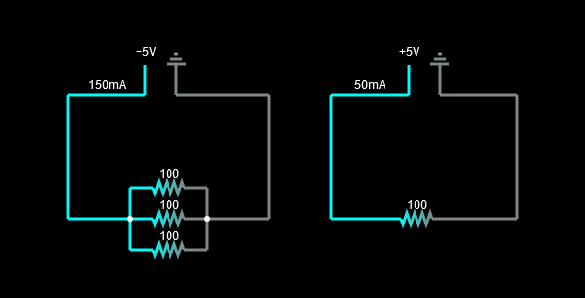 Equivalent Resistance Formula (Re):

* + For different resistors: $\frac{1}{Rp}=\frac{1}{R1}+\frac{1}{R2}+\frac{1}{R3}$
  + For resistors of the same type: $Rp= \frac{R}{n}$

Formula for direct current (I):

* I: U $∙$ Re

If we have different values for the three resistors in the second drawing, then the value of the equivalent resistance Re in the first drawing is the arithmetic mean of these values. $Re= \frac{R1+R2+R3}{3}$

Table of the three resistors connected in parallel

|  |  |  |  |  |  |  |
| --- | --- | --- | --- | --- | --- | --- |
| Ordine | R1 (Ω) | R2 (Ω) | R3 (Ω) | Re (Ω) | E (V) | I (mA) |
| 1. | 100 | 100 | 100 | 33.33 | 5 | 150 |
| 2. | 75 | 75 | 75 | 24.44 | 5 | 200 |
| 3. | 31 | 31 | 31 | 10.33 | 5 | 483.87 |
| 4. | 60 | 60 | 60 | 20 | 5 | 250 |
| 5. | 99 | 99 | 99 | 33 | 5 | 151.51 |
| 6. | 90 | 90 | 90 | 30 | 5 | 166.66 |
| 7. | 134 | 136 | 50 | 28.72 | 5 | 174.07 |
| 8. | 51 | 51 | 52 | 17.10 | 5 | 292.23 |
| 9. | 82 | 82 | 82 | 27.33 | 5 | 182.92 |
| 10. | 14 | 13 | 17 | 4.82 | 5 | 1036 |